**Math and Bitmanipulation**

**Math**

1.Extended Euclidean Algorithm(Gcd and Hcf)

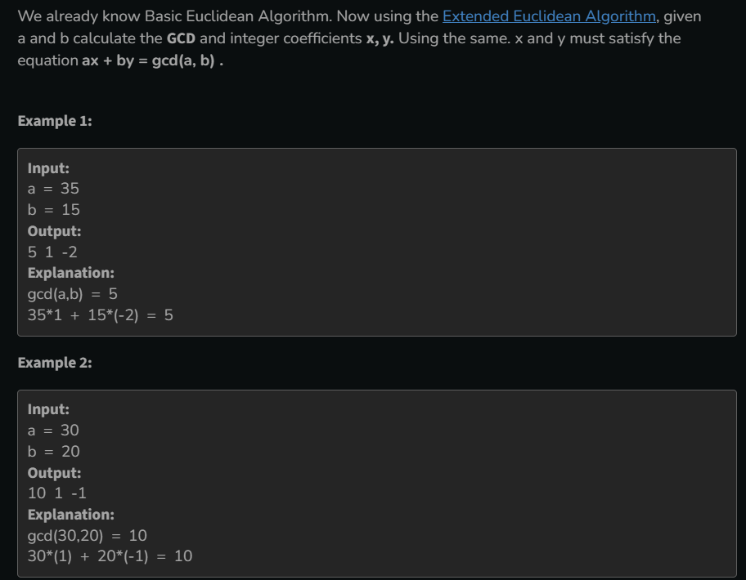

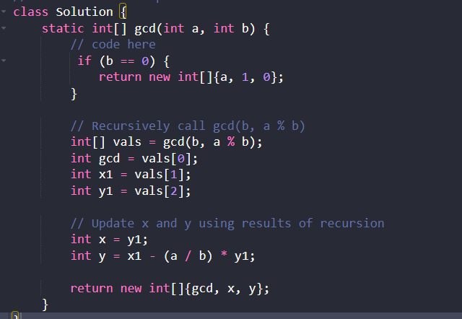

2.Sieve of Eratosthenes

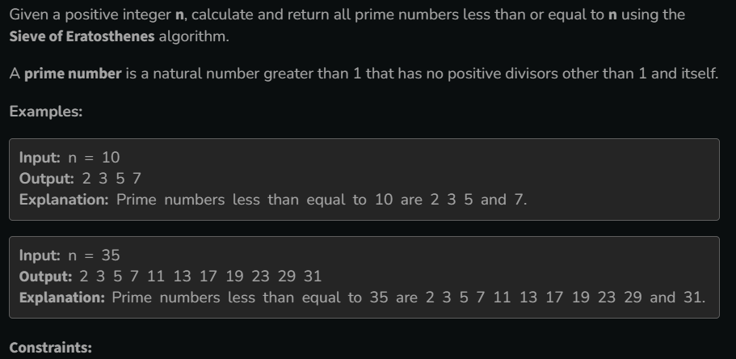

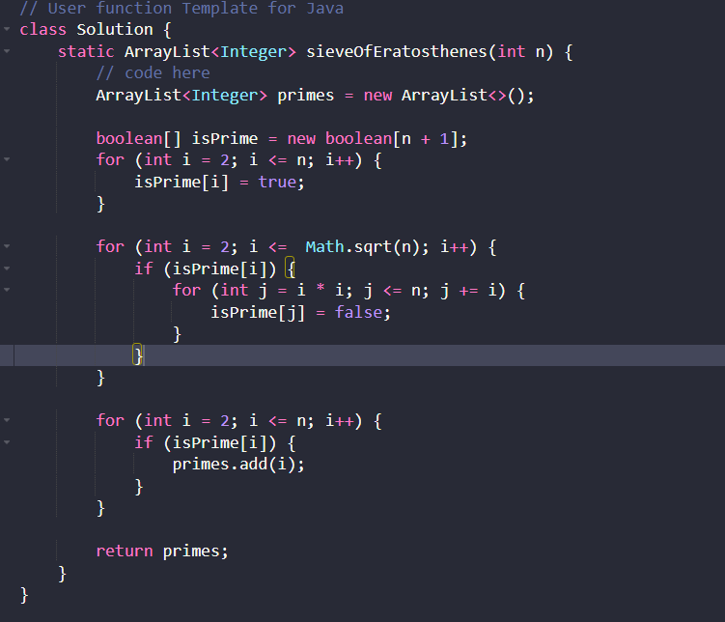

4.Nth Fibonacci Number

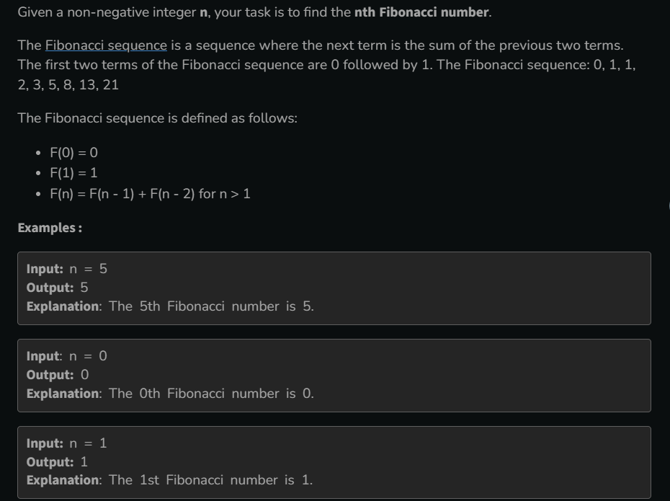

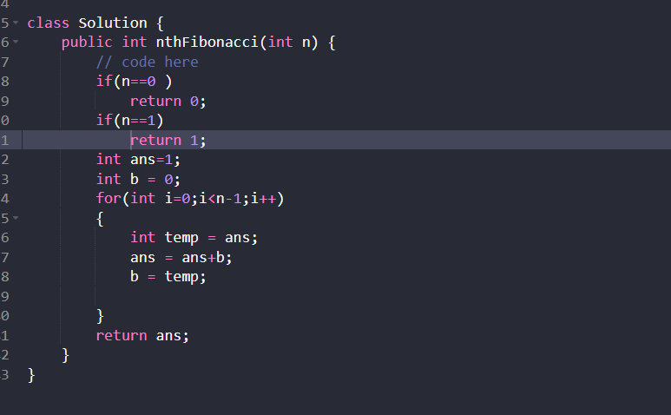

4.Euler Totient Function

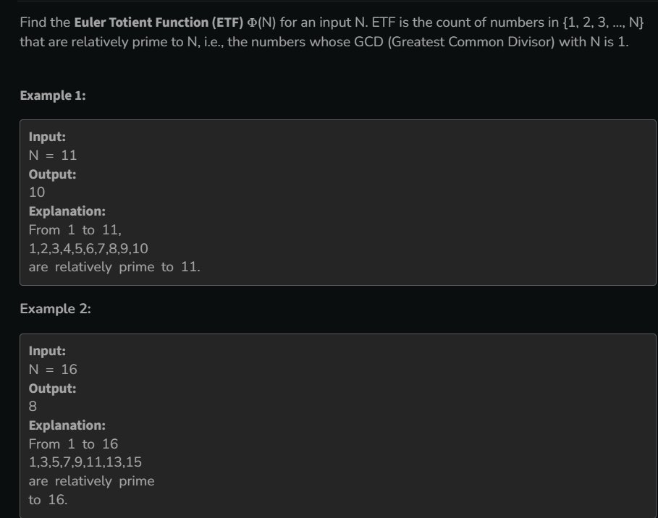

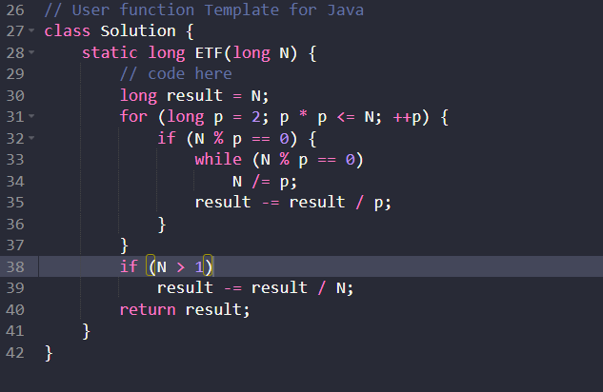

Learn About Catalan Number(Imp)

<https://www.geeksforgeeks.org/catalan-numbers/>

3.Learn About Modular Arithmetic

<https://www.geeksforgeeks.org/modular-arithmetic/>

Learn About Prime Factorisation

<https://www.geeksforgeeks.org/prime-factorization/>

Learn About Chinese remainder theorem

<https://www.geeksforgeeks.org/chinese-remainder-theorem/>

**Bit Manipulation**

**1.Count set bit in an integer(No. of 1 bit)**

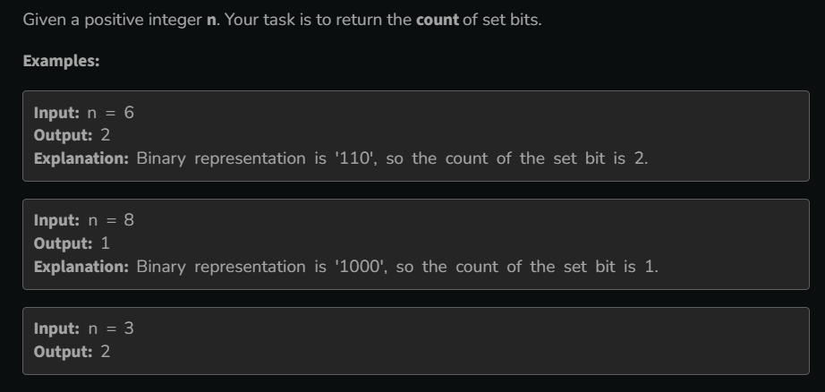

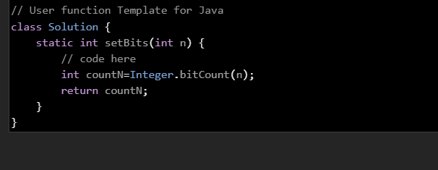

**2.Bit difference**

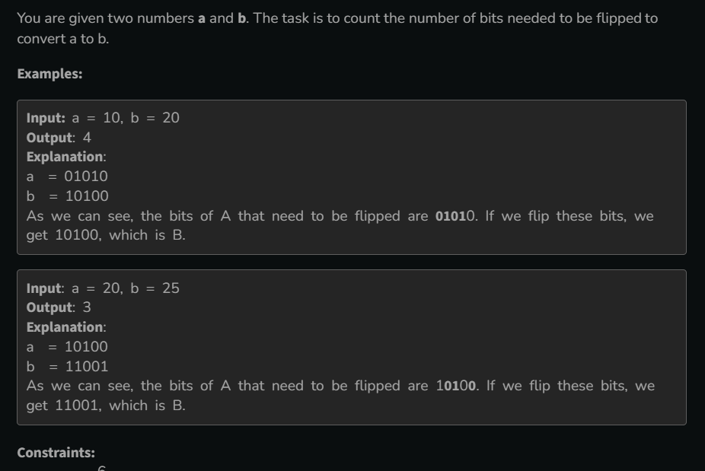

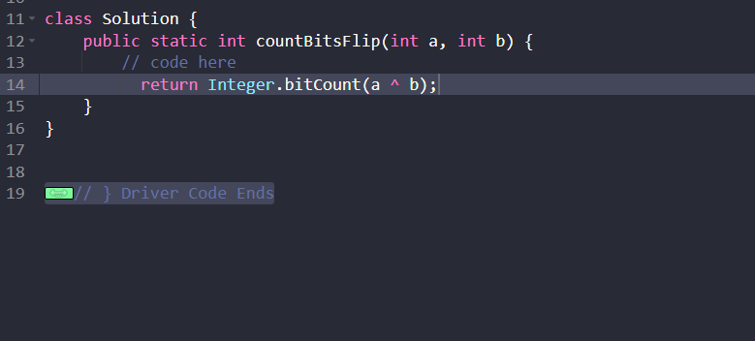

**3.Count total Set bits**

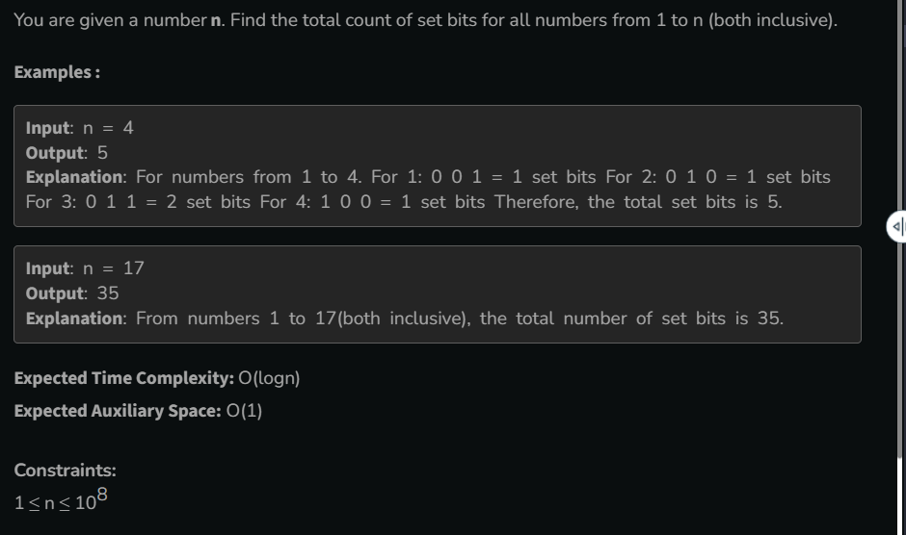

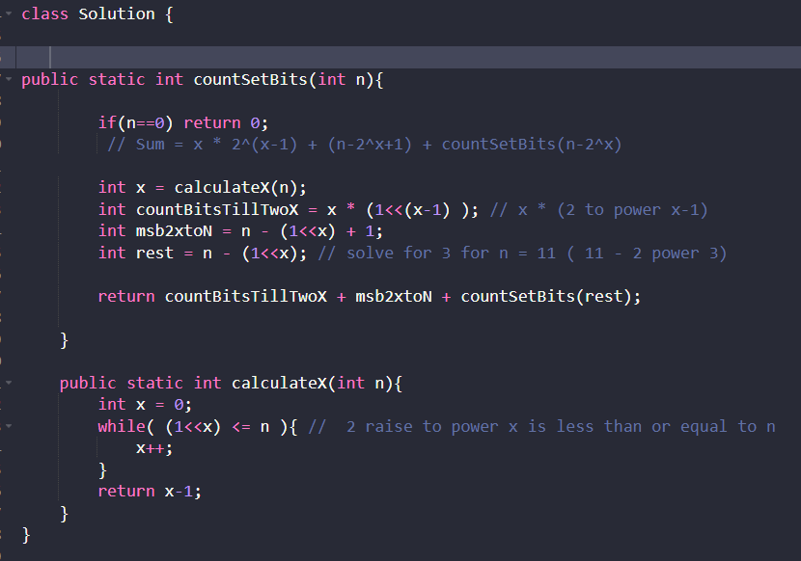

**4.Find Position of set bit**

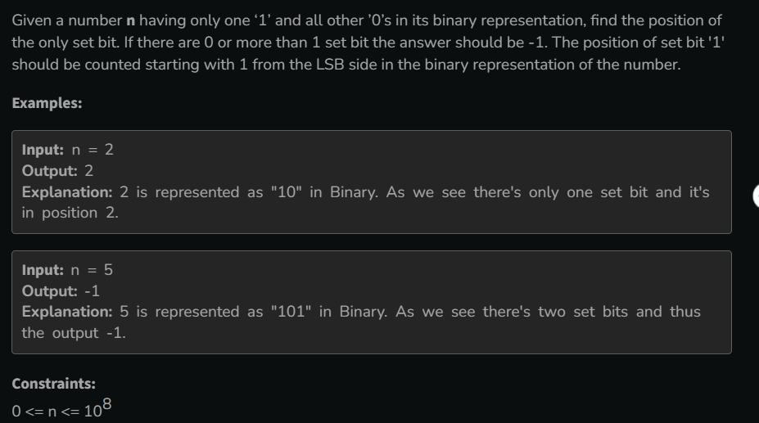

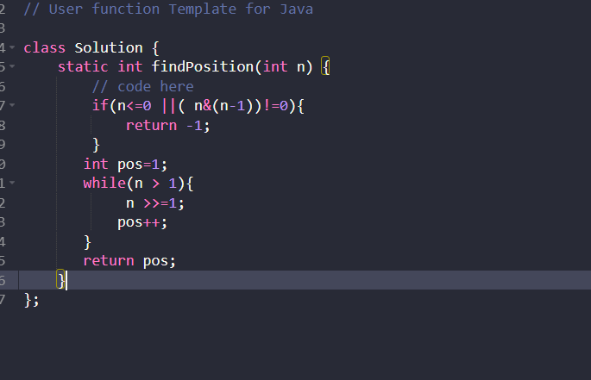

**5.Copy set bit in range**

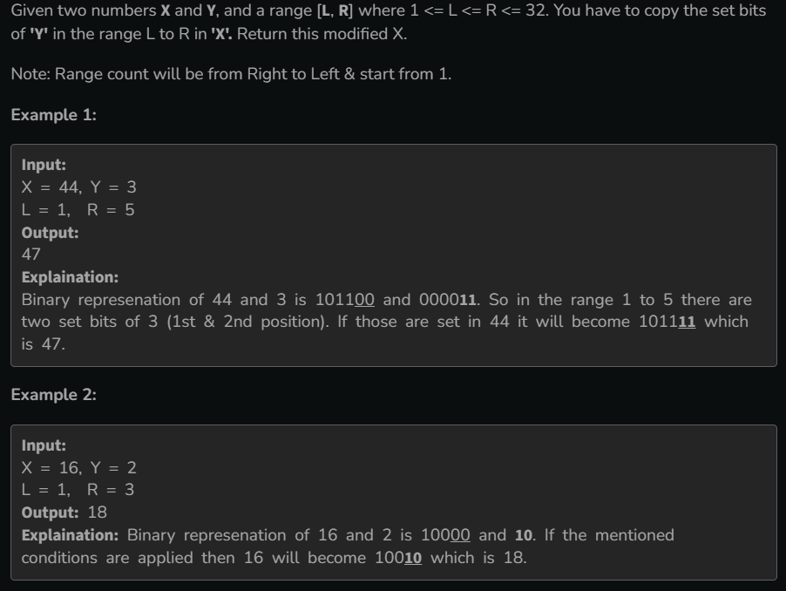

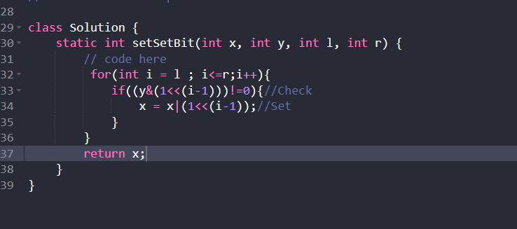

**6.Power Set**

